Usiel Figueroa

M11: Programming Assignment

CSD402-A311 Java for Programmers

February 24, 2025

**JavaFX BorderPane and ScrollPane**

Graphics and media packages with JavaFX improved multimedia support, making it a preferred choice for contemporary applications. Among its many layout components, the BorderPane and ScrollPane classes are widely used for designing structured and scrollable interfaces. This paper explores these two JavaFX components, common methods, and explanations and provides examples of their use and combined usage. JavaFX BorderPane and ScrollPane deliver a seamless way to create dynamic user interfaces by manipulating their built-in layout, which helps design visually appealing and highly functional applications.

**JavaFX BorderPane**

The BorderPane class in JavaFX is a layout component that arranges nodes in five distinct regions: top, bottom, left, right, and center. It provides a structured way to design user interfaces by placing elements in predefined positions, allowing for a clean and organized layout (Oracle, n.d.). BorderPane layout makes it an essential layout manager for applications that require well-defined sections, such as dashboards, forms, and control panels. The BorderPane layout is advantageous for applications that need clear distinctions between different interface elements while maintaining flexibility and responsiveness (Liang, n.d.).

**Example**

**BorderPane**

Oracle docs provide a great illustration of how BorderPane is crucial for layout landscaping. According to the article, "The top and bottom children will be resized to their preferred heights and extend the width of the border pane. The left and right children will be resized to their preferred widths, and the length between the top and bottom nodes will be extended. The center node will be resized to fill the available space in the middle. Any of the positions may be null" (Oracle, n.d.)

"BorderPane lays out children in top, left, right, bottom, and center positions" (Oracle, n.d.).

Image source link: <https://docs.oracle.com/javase/8/javafx/api/javafx/scene/layout/BorderPane.html>

**Common Methods of BorderPane**

| Methods | Explanation |
| --- | --- |
| getAlignment(Node c) | Returns the alignment of the node. |
| getBottom() | Returns the bottom node of the border pane. |
| getCenter() | Returns the center node of the border pane. |
| getLeft() | Returns the left node of the border pane. |
| getRight() | Returns the right node of the border pane. |
| getTop() | Returns the top node of the border pane. |
| setAlignment(Node c, Pos v) | Sets the alignment of node c to pos v. |
| setBottom(Node v) | Sets the bottom node of the border pane. |
| setCenter(Node v) | Sets the center node of the border pane. |
| setLeft(Node v) | Sets the left node of the border pane. |
| setRight(Node v) | Sets the right node of the border pane. |
| setTop(Node v) | Sets the top node of the border pane. |

Source link: <https://www.geeksforgeeks.org/javafx-borderpane-class/>

**JavaFX ScrollPane**

The ScrollPane class is used in Java to create access to content that is out of sight from the user-viewable pane; thus, scrollable functions provide access to hidden data. It is beneficial for displaying images, long texts, or large lists within a confined area (Oracle, n.d.). The ScrollPane ensures users can navigate through extensive content smoothly without cluttering the UI. Scroll functionality is essential for applications that handle large data sets or media files that extend beyond the default viewing area (Tutorialspoint, n.d.).

**Sample**

**ScrollPane**

The example below illustrates the primary function of a ScrollPane in JavaFX; it lets the user and designer display the image in a manner where the main pane is visible to some extent, in this case, a photo of a boy riding an elephant in the jungle, displaying in the pane are not at the full dimensions however the bar arrows allow access to all the image corners. "A scroll pane holds a UI element and provides a scrollable view. In JavaFX, you can create a scroll pane by instantiating the favafx.scene.control.ScrollPane class. Programmers can set content to the scroll pane using the setContent() method" (Tutorialspoint, n.d.).

Image source link: <https://www.tutorialspoint.com/how-to-create-a-scroll-pane-using-javafx>

**Common Methods of ScrollPane**

| Methods | Explanation |
| --- | --- |
| [HScroll](https://support.smartbear.com/testcomplete/docs/reference/test-objects/members/window-and-process/hscroll-property-window-object.html) | Returns a [ScrollBar](https://support.smartbear.com/testcomplete/docs/reference/test-objects/controls/desktop/general/scroll-bar/index.html) object that provides a scripting interface to the control's horizontal scroll bar. |
| [JavaFXPopupMenu](https://support.smartbear.com/testcomplete/docs/reference/test-objects/members/java-fx/javafxpopupmenu-property-javafx-object.html) | Returns the [Menu](https://support.smartbear.com/testcomplete/docs/reference/test-objects/controls/desktop/general/menu/index.html) object that provides a scripting interface to the control's context menu (the menu must be opened first). |
| [VScroll](https://support.smartbear.com/testcomplete/docs/reference/test-objects/members/window-and-process/vscroll-property-window-object.html) | Returns a [ScrollBar](https://support.smartbear.com/testcomplete/docs/reference/test-objects/controls/desktop/general/scroll-bar/index.html) object that provides a scripting interface to the control's vertical scroll bar. |

Source link: <https://support.smartbear.com/testcomplete/docs/reference/test-objects/controls/desktop/java-fx/scroll-pane/properties.html>

**Usiel's Program example**

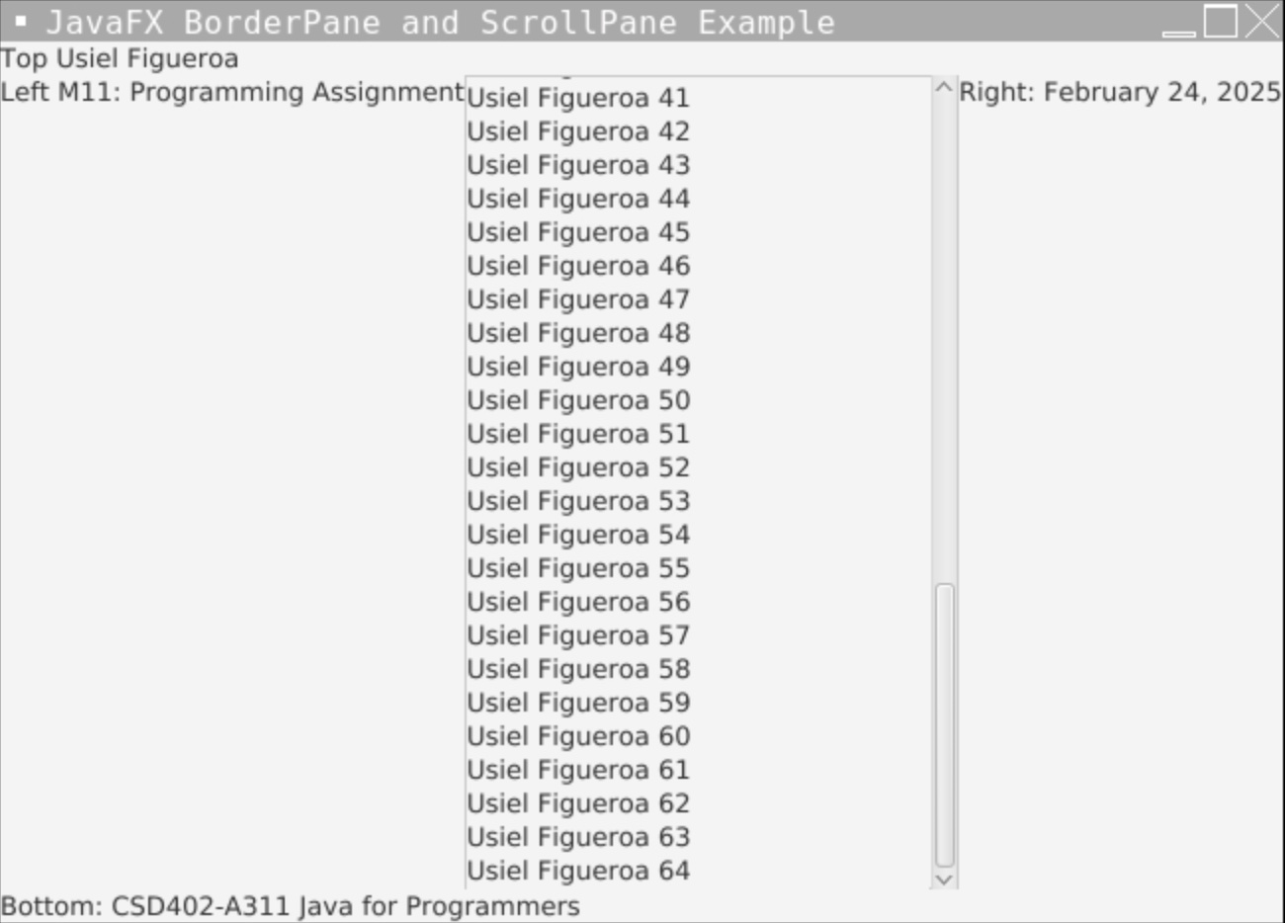

JavaFX/ Main BorderPane and ScrollPane Example/ Author: Usiel Figueroa

The above Usiel example in the JavaFX program demonstrates the use of BorderPane and ScrollPane to create a simple graphical user interface. BorderPane is the root layout, which organizes UI components into five regions with the assignment information: top authors' full name, bottom course description, left assignment number, right date, and center ScrollPane. Static labels are assigned to the top, bottom, left, and right areas. At the same time, the center contains a ScrollPane with a VBox with multiple labeled lines of my full name incrementing to the number 64 to simulate scrollable content. The ScrollPane ensures that when content exceeds the visible area, users can scroll through it. The start method initializes the UI components and sets up a scene of size 646x444 pixels. The main method is processed with the application, displaying the intended results output the interface with labeled areas with the author and class descriptions and a scrolling section in the center with the name displaying Usiel Figueroa multiple times.

**Conclusion**

JavaFX's BorderPane and ScrollPane classes provide fundamental preset functions to structure and manage user interface elements or applications. The BorderPane provides a well-organized layout with distinct regions: top, bottom, left, right, and center. At the same time, the ScrollPane offers programmers quick results for displaying significant content or data within a confined space. Programmers can create and combine many JavaFX components to output visual and functional applications for the intended use.

**References**

[Design and Development - Video Production]. (2020, November 9). JavaFX Intro [Video]. Bellevue University. <https://bellevue.mediaspace.kaltura.com/media/JavaFX+Intro/1_tv5kbdpm>

Liang, Y. D. (n.d.). Introduction to Java Programming and Data Structures, Comprehensive Version. Retrieved from <https://platform.virdocs.com/read/2229015/247/#/4/2[P700101715900000000000000000907D]/2/2[P700101715900000000000000000907E]/2,/1:0,/1:0>

(2014, August 1). JavaFX. Oracle. Retrieved February 17, 2025, from chrome-extension://efaidnbmnnnibpcajpcglclefindmkaj/https://docs.oracle.com/javase/8/javafx/JFXST.pdf

(n.d.). Class BorderPane. Oracle. Retrieved February 17, 2025, from <https://docs.oracle.com/javase/8/javafx/api/javafx/scene/layout/BorderPane.html>

Oracle and/or its affiliates (n.d.). Public class BorderPane. Oracle. Retrieved February 25, 2025, from https://openjfx.io/javadoc/13/javafx.graphics/javafx/scene/layout/BorderPane.html

(2021, September 1). JavaFX | BorderPane Class. Geeksforgeeks.org. Retrieved February 25, 2025, from https://www.geeksforgeeks.org/javafx-borderpane-class/

(2025, February 5). JavaFX ScrollPane Properties. Smartbear.com. Retrieved February 25, 2025, from <https://support.smartbear.com/testcomplete/docs/reference/test-objects/controls/desktop/java-fx/scroll-pane/properties.html>

(n.d.). Class ScrollPane. Oracle. Retrieved February 17, 2025, from <https://docs.oracle.com/javase/8/javafx/api/javafx/scene/control/ScrollPane.html>

(n.d.). How to create a scroll pane using JavaFX? Tutorialspoint.com. Retrieved February 17, 2025, from [https://](https://www.tutorialspoint.com/how-to-create-a-scroll-pane-using-javafx)www.tutorialspoint.com/how-to-create-a-scroll-pane-using-javafx